Q1:

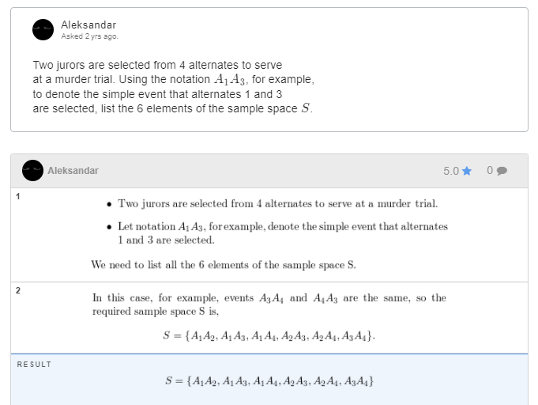

Q2

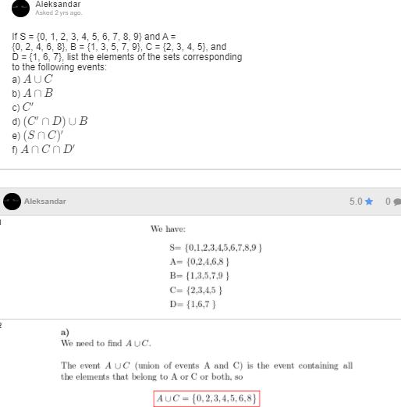

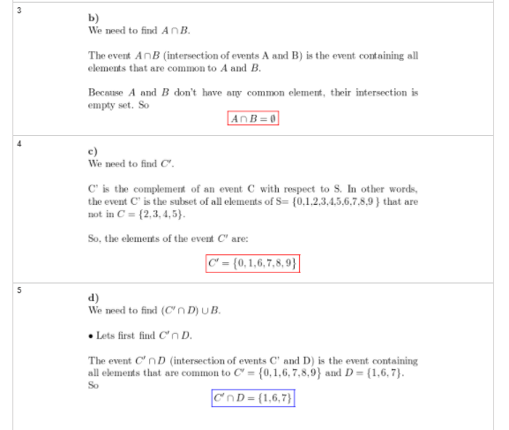

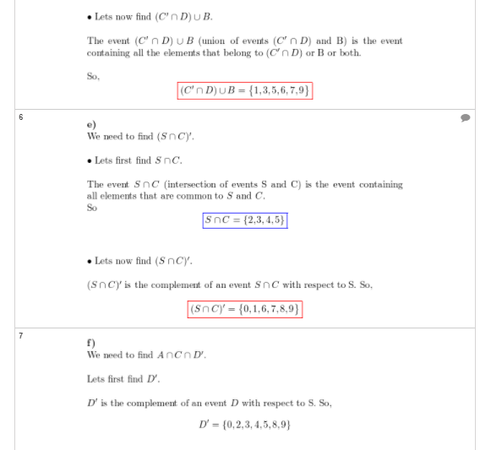

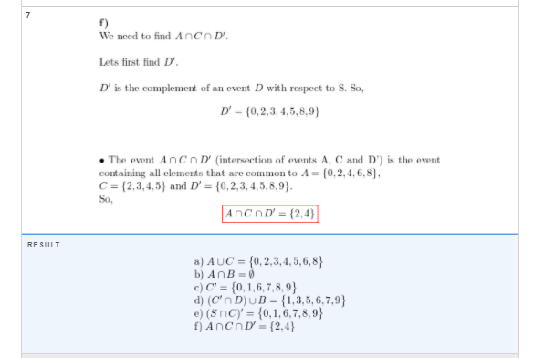

Q3

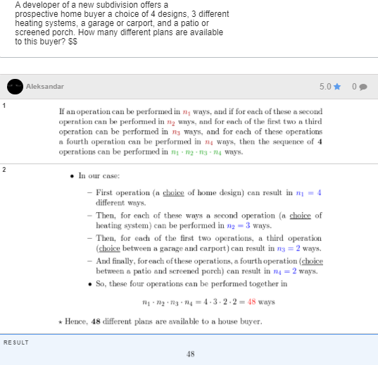

Q4

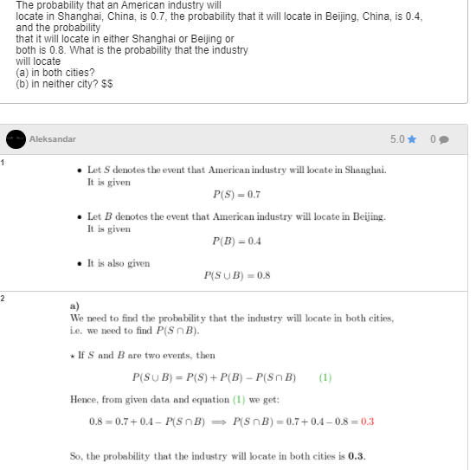

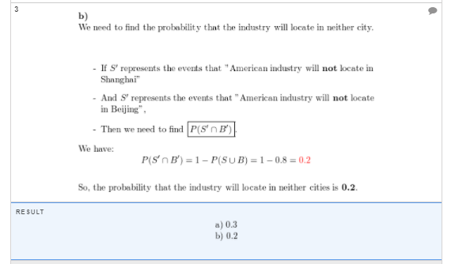

Q5

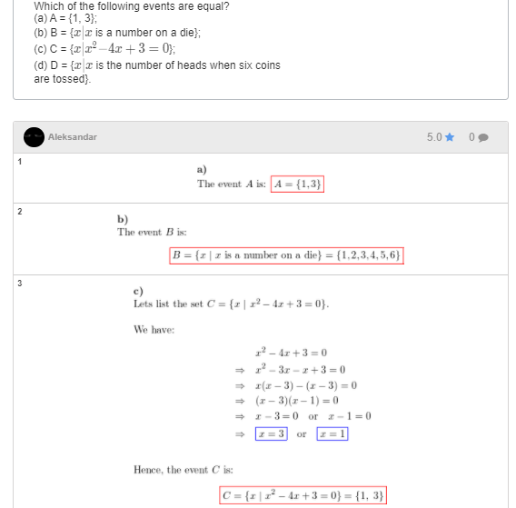

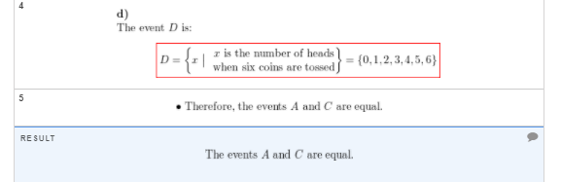

Q6

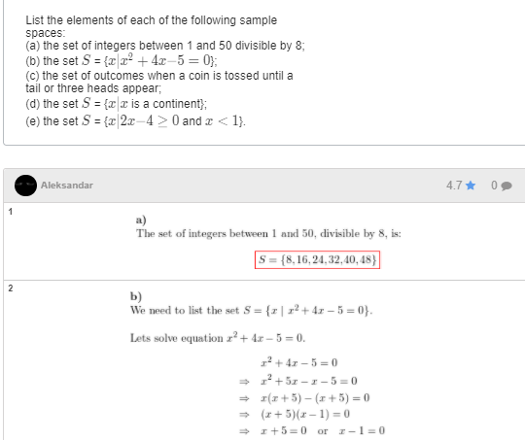

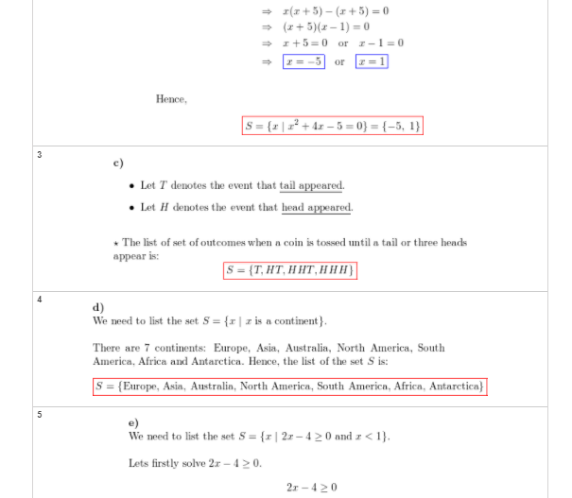

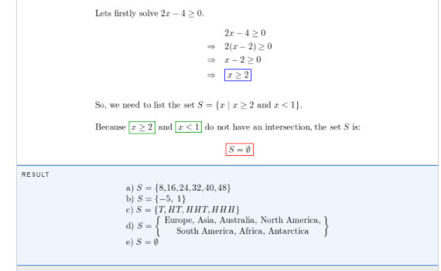

Q7 -**\*\*\*(switch between customer and car hotel and gas station )**

The probabilities that a service station will

pump gas into 0, 1, 2, 3, 4, or 5 or more cars during

a certain 30-minute period are 0.03, 0.18, 0.24, 0.28,

0.10, and 0.17, respectively. Find the probability that

in this 30-minute period

(a) more than 2 cars receive gas;

(b) at most 4 cars receive gas;

(c) 4 or more cars receive gas.

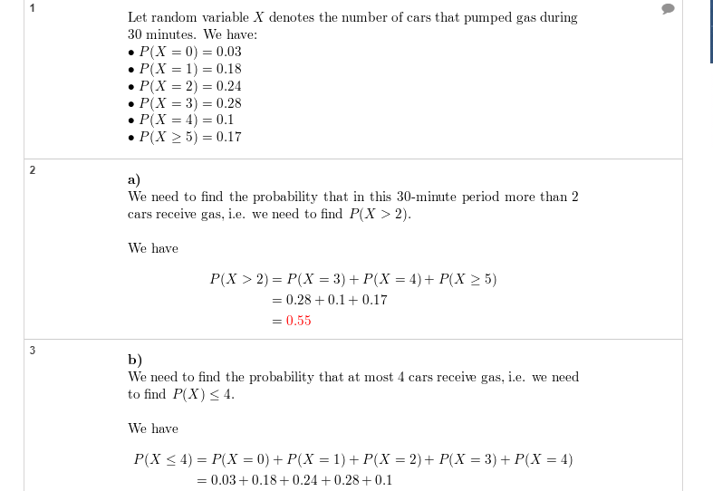

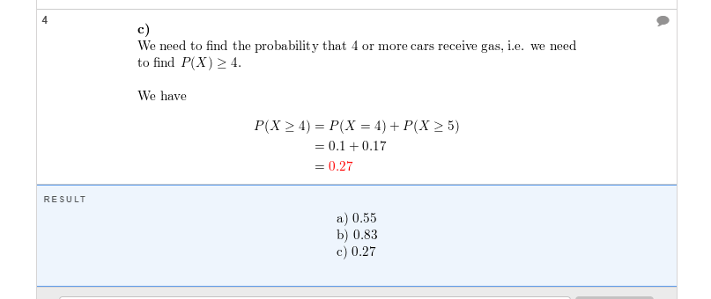

Q8

In a certain federal prison, it is known that

2/3 of the inmates are under 25 years of age. It is

also known that 3/5 of the inmates are male and that

5/8 of the inmates are female or 25 years of age or

older. What is the probability that a prisoner selected

at random from this prison is female and at least 25

years old?

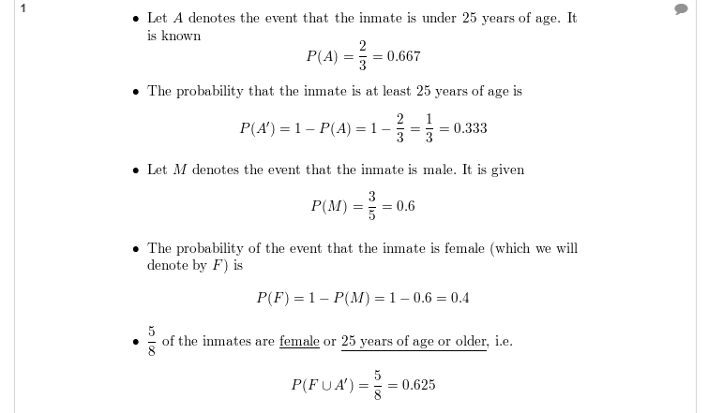

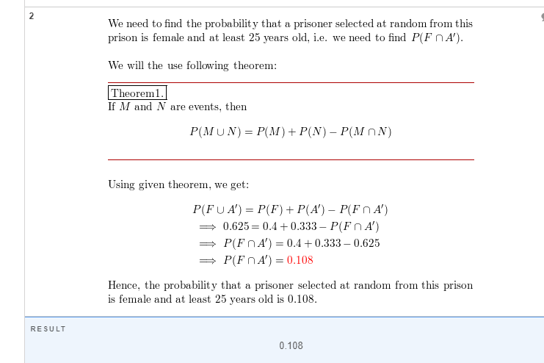

Q9

The probability that an automobile being filled with gasoline also needs an oil change is 0.25; the probability that it needs a new oil filter is 0.40; and the probability that both the oil and the filter need changing is 0.14. (a) If the oil has to be changed, what is the probability that a new oil filter is needed? (b) If a new oil filter is needed, what is the probability that the oil has to be changed?

Solution:

**P(B | A) = probability of B given A**

**P(B | A) = P(B and A) / P(A)**

**Thus = .14/.25 = dil karna for filter change**

**P(new oil filter | oil change) = P(both) / P(oil change)**

**= 0.14 / 0.25 = dil karna for oil n gasoline**

**(b) = 0.14 / 0.4**